**Explain about Data warehouse and the necessary Steps to Implement Data Warehouse and list out its components & Tools.**

* A data warehouse is a centralized system used for storing and managing large volumes of data from various sources. for analysis and reporting. .
* It is designed to help businesses analyze historical data and make informed decisions.
* Data from different operational systems is collected, cleaned, and stored in a structured way, enabling efficient querying and reporting.
* It ensures **data is accurate, secure, and easy to use**, helping businesses **track past performance, find patterns, and make informed decisions**.

**Diagram:**

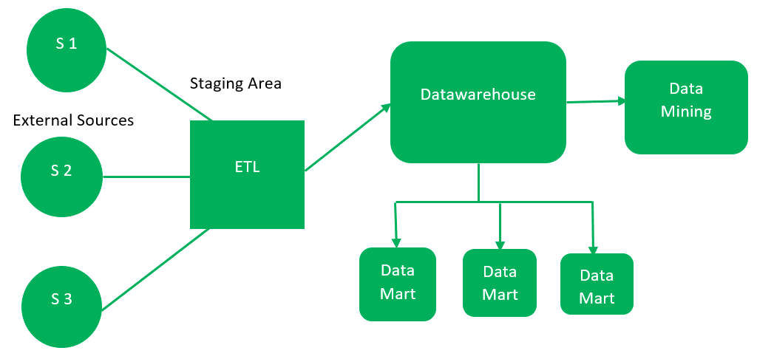

**Steps in Data Warehouse Implementation**

1. **Planning and Requirements Gathering:** Understand business needs, set objectives and determine hardware/software requirements.
2. **Data Modeling and Design:** Choose the appropriate schema (e.g., [Star](https://www.geeksforgeeks.org/star-schema-in-data-warehouse-modeling/), [Snowflake](https://www.geeksforgeeks.org/snowflake-schema-in-data-warehouse-model/)) to optimize data organization and query performance.
3. **ETL Process: Extract, Transform and Load:** Extract, clean, transform and load data, ensuring consistency and accuracy, with customized [ETL tools](https://www.geeksforgeeks.org/etl-process-in-data-warehouse/).
4. **Database Design and Architecture:** Design the physical [architecture](https://www.geeksforgeeks.org/data-warehouse-architecture/), including storage, indexing and optimization for efficient performance.
5. **Data Warehouse Development:** Create tables, views and other objects, ensuring scalability for future data growth.
6. **Testing and Validation:** Verify data accuracy and performance, ensuring the system meets requirements and resolving any discrepancies.
7. **Deployment and Maintenance:** Deploy the system, address issues, apply updates and maintain continuous data integration.

**Components of Data Warehouse**

* **Data Sources**: These are the various [operational systems,](https://www.geeksforgeeks.org/difference-between-operational-systems-and-informational-systems/) databases, and external data feeds that provide raw data to be stored in the warehouse.
* **ETL (Extract, Transform, Load) Process**: The [ETL process](https://www.geeksforgeeks.org/etl-process-in-data-warehouse/) is responsible for extracting data from different sources, transforming it into a suitable format, and loading it into the data warehouse.
* **Data Warehouse Database**: This is the central repository where cleaned and transformed data is stored. It is typically organized in a multidimensional format for efficient querying and reporting.
* **Metadata**: [Metadata](https://www.geeksforgeeks.org/what-is-metadata/)describes the structure, source, and usage of data within the warehouse, making it easier for users and systems to understand and work with the data.
* **Data Marts**: These are smaller, more focused data repositories derived from the data warehouse, designed to meet the needs of specific business departments or functions.
* **OLAP (Online Analytical Processing) Tools**: [OLAP tools](https://www.geeksforgeeks.org/olap-servers/) allow users to analyze data in multiple dimensions, providing deeper insights and supporting complex analytical queries.
* **End-User Access Tools**: These are reporting and analysis tools, such as dashboards or [Business Intelligence (BI) tools](https://www.geeksforgeeks.org/what-is-business-intelligence/), that enable business users to query the data warehouse and generate reports.

**Advantages of Data Warehouse**

1. **Better Decision Making**: Helps in making informed business decisions with accurate reports.
2. **Data from Multiple Sources**: Combines data from different systems like sales, marketing, finance, etc.
3. **Faster Query Performance**: Answers complex questions quickly using historical data.
4. **Improved Data Quality**: Cleans and organizes the data for better accuracy.
5. **Support for Business Intelligence (BI)**: Works well with tools like Power BI, Tableau for dashboards and reports.

**Disadvantages of Data Warehouse**

1. **High Cost**: Building and maintaining a data warehouse can be expensive.
2. **Complex Setup**: Requires technical knowledge and time to design and implement.
3. **Data Delay**: Data is not always real-time; it's usually updated in batches.
4. **Difficult to Change**: Once the structure is built, making changes can be hard and risky.
5. **Not for Small Data**: Best suited for big and historical data, not small or simple data needs.

**List of Data Warehouse Tools**

**ETL (Extract, Transform, Load) Tools:**

|  |  |
| --- | --- |
| **Tool** | **Use** |
| **Talend** | Open-source tool to move and clean data. |
| **Informatica** | Popular enterprise ETL tool. |
| **Apache Nifi** | Drag-and-drop tool for data flow. |
| **Microsoft SSIS** | ETL tool from Microsoft for SQL Server. |

**Data Warehouse Platforms:**

|  |  |
| --- | --- |
| **Tool** | **Description** |
| **Amazon Redshift** | Cloud warehouse by Amazon. |
| **Google BigQuery** | Fast, serverless data warehouse by Google. |
| **Snowflake** | Cloud-based, easy-to-scale warehouse. |

**BI / Visualization Tools:**

|  |  |
| --- | --- |
| **Tool** | **Purpose** |
| **Power BI** | Create dashboards and reports. |
| **Tableau** | Visualize data easily with drag-and-drop. |